

**School of Information Technology**

**Department of AI & Data Science**

**Programming Language (2)**

**601212**

**LADIES_GYM**

**Introduction**

In the era of modern technology, the Python programming language has become one of the most important tools used in software development and problem solving.

This report provides an overview of the project carried out during the semester using the Python programming language.

During this semester, many concepts and techniques in the field of : data structures such as list or tuples, loops, user-defined functions, built-in functions, and exception handling

GUI interface (using tkinter ) .

The project aims to apply what has been completed throughout the semester and develop practical skills using it.

By creating a number of pages using the GUI and moving between them.

Ladies gym project consists of 4 screens:

* The first screen is a “**login page** “

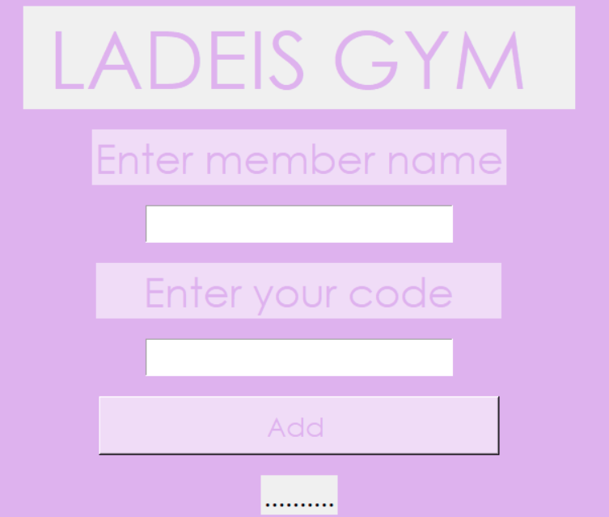

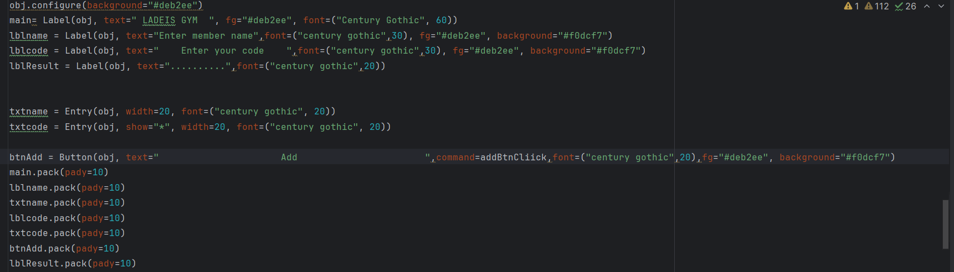

-With this code , we specify the type of boxes (buttons) ,texts ,the colors of the page ,buttons using the properties(fg,background), and the size of each.

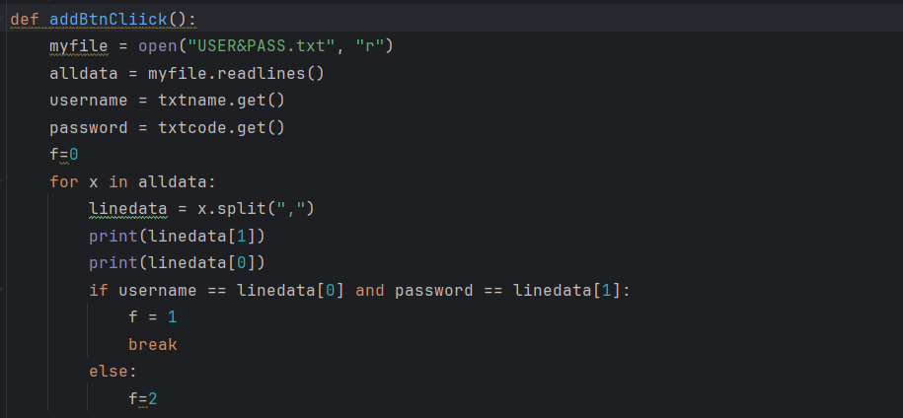

**addBtnClick Function:**

You open the file "USER&PASS.txt" for reading and read all data from it, user inputs **txtname** and **txtcode** are used to get the username and password.

It examines the read data to check if there is a match with the user data, If a match is found, a new user interface is displayed using **Tkinter.**

* The second screen is a “**List of available services for customers** “ :

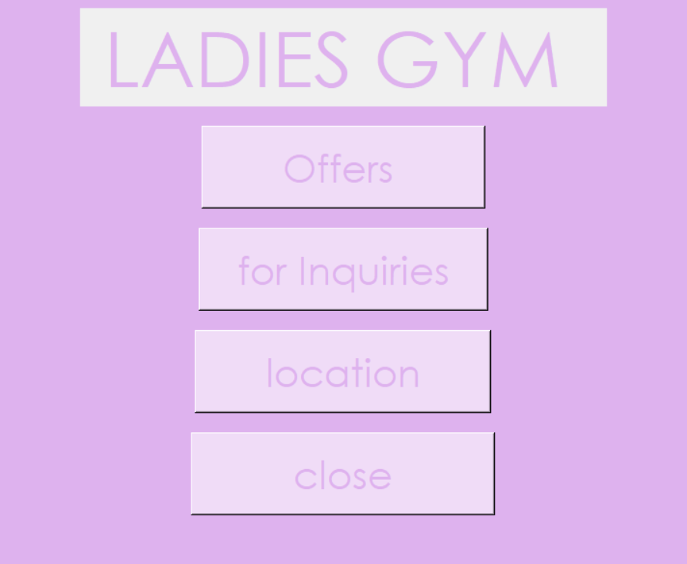

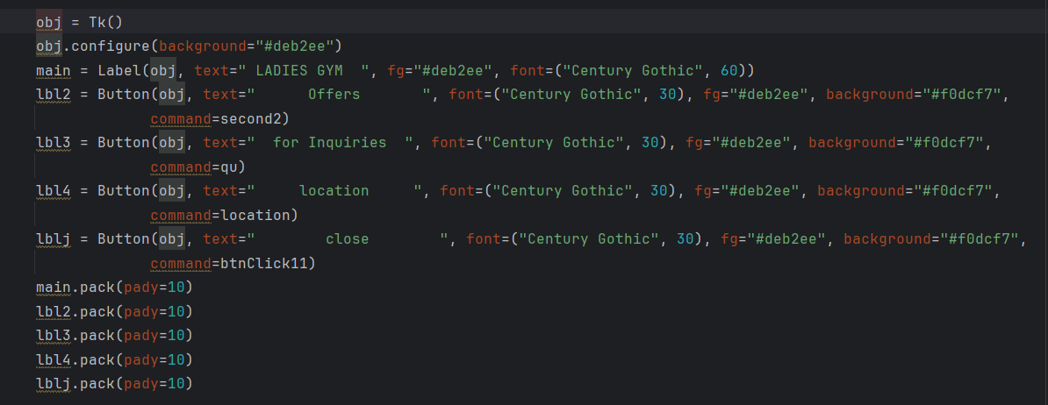

- User interfaces **Qu , location , second 2 , and btnClick11**:

You are located in sub-windows to provide additional information about the sports club, offers, offers, and location.

They contain labels, buttons, and text.

* The third screen is **the results of pressing the buttons on the second screen:**
* Offers Button next page :

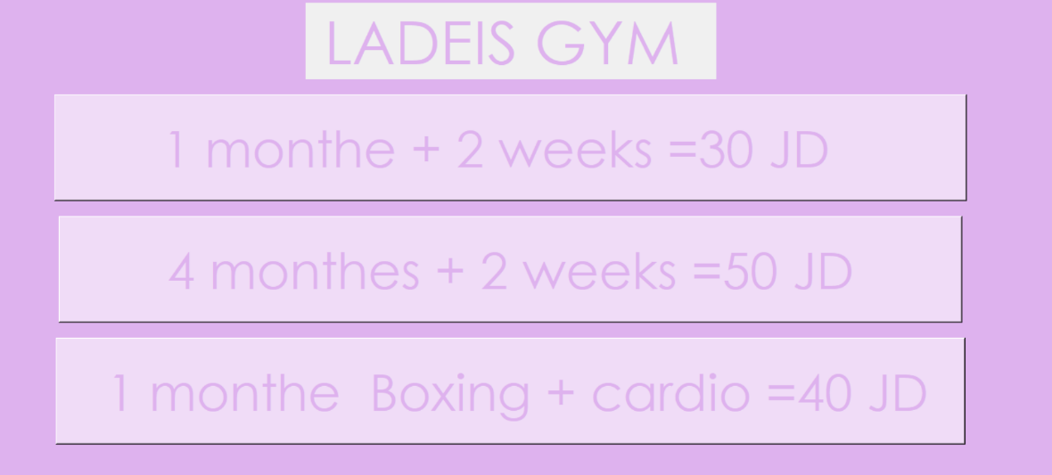

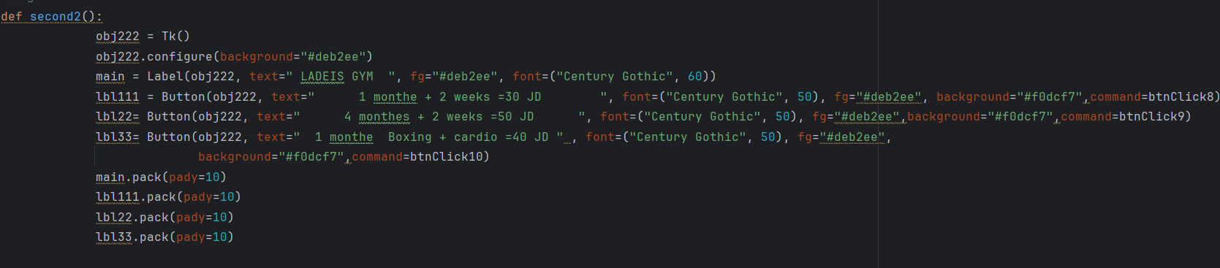

-The second2 function is used to create and display the women's fitness club offers sub-UI. I will explain the code in detail:

Create a new window (obj222):

obj222 = Tk(): Creates a new window using Tk().

Configure window properties: for the child window.

Create and configure the user interface within the subwindow:

main=Label(obj222,text="LADEISGYM",fg="#deb2ee", font=("Century Gothic", 60)): Creates a Label element containing the text "LADEIS GYM", configure some properties such as text color and size Line, This applies to all items.

Order and display items:

main.pack ( pady=10) : Displays the main element in the child window with horizontal spacing.

The functions btnClick8, btnClick9, and btnClick10 are the functions associated with each button respectively, and they are called when the user clicks on any of these buttons.

* For Inquires Button next page:



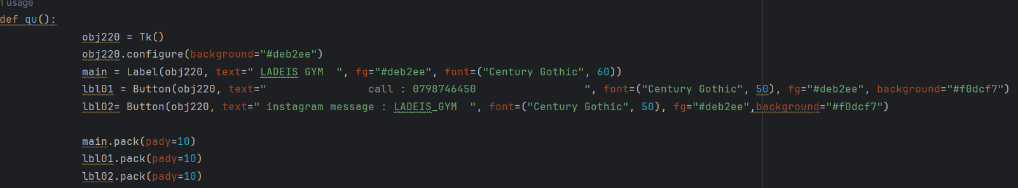

-Create a new window (obj220):

obj220 = Tk(): You create a new window using Tk(). Configure window properties: "obj220.configure" sets the background color for the child window, As well as the elements, as mentioned above.

This interface contains contact information for the women's fitness club, where the user can call the specified number or send a message via Instagram.

* **For Location Button next page:**

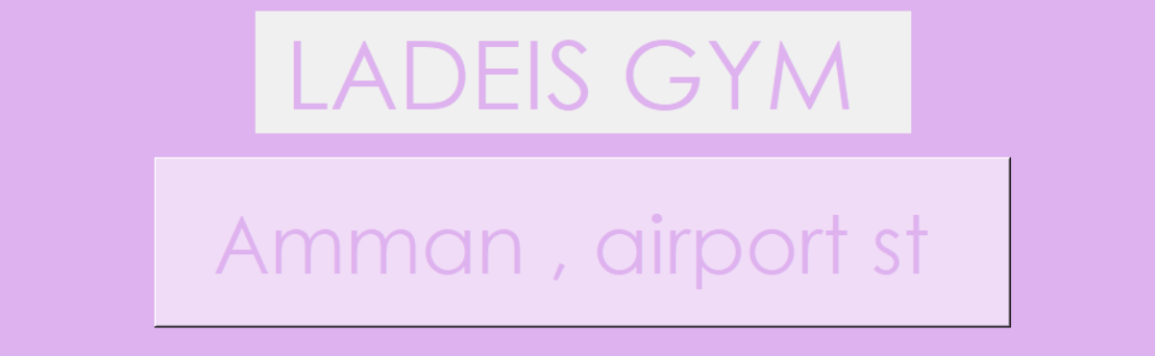

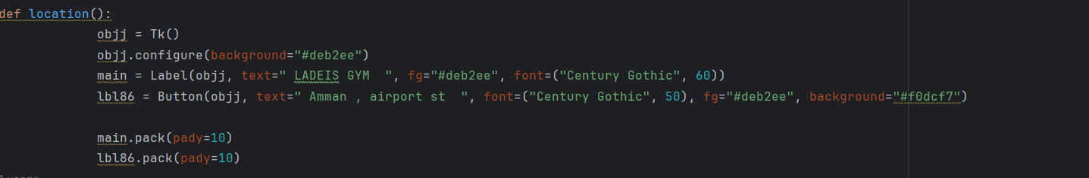

-This interface contains information about the location of the

women's fitness club, where the user can see the location of the

club and the specific address.

By creating a new window (obj): **obj = Tk()**

Configure window properties: **obj. configure**

Create and configure the user interface within the

Sub window: **main = Label()**

Arrange and display items: Such as **main.pack**

* **Close Button next page:**

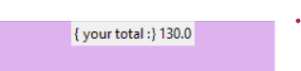

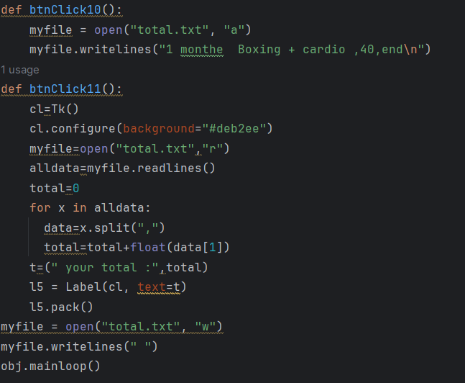

-Create a new window (cl): cl = Tk()

Configure window properties: cl.configure() ,

reading data from "total.txt" file: myfile = open("total.txt", "r"): Opens the file "total.txt" for reading.

alldata = myfile.readlines(): It reads all the data from the file and puts it in the alldata list. Calculate the total: total = 0: Initializes the total variable to store the total.

for x in alldata:: Iterates through the alldata list.

data = x.split(","): Splits each line in the file into elements using the comma ",".

total = total + float(data[1]): Sums the numeric values ​​at the second position (index 1) on each line.

Create a Label element to display the result: t = ("your total:", total): Creates a text containing the text "your total:" with the total value.

l5 = Label(cl, text=t): Creates a Label element to display text t.

l5.pack(): The l5 item is displayed in the subwindow.

Close the "total.txt" file: myfile.close(): Closes the "total.txt" file after it has finished reading it. Rewrite the file "total.txt":

myfile = open("total.txt", "w"): Opens the "total.txt" file for writing.

myfile.writelines(" "): Writes a blank line to the file to empty it of previous data.

Run main loop (cl.mainloop()): cl.mainloop(): Runs the main loop to activate the child UI and wait for user interaction.

JOUD ZAHER AL-HALLAQ

202210984